JY213H 600V Three-Phase Gate Driver IC（SOP-20 Package）

Overview
The JY213H is a high-speed power MOSFET and IGBT driver featuring three independent high-side and low-side output channels for three-phase gate driving applications.
The chip integrates built-in dead time and shoot-through protection, effectively preventing damage to the half-bridge circuit. To avoid damage to the power devices caused by low supply voltage operation, an internal undervoltage lockout (UVLO) circuit is included.
With advanced high-voltage BCD process technology and built-in common-mode noise cancellation, the high-side driver can operate stably even in high dv/dt noise environments.

Features
- Integrated 600V three-phase half-bridge high-side and low-side drivers
- Built-in dead time
- Integrated shoot-through protection
- Undervoltage lockout (UVLO) for both high-side and low-side drivers
- Compatible with 3.3V, 5V, and 15V logic levels
- Dead time: 0.1 μs (typ.)
- Excellent dv/dt common-mode noise immunity
- Capable of withstanding negative transient voltages
- Operating temperature range: -40°C to 125°C

3. Applications
- Brushless DC motor (BLDC) drive systems
- Other three-phase inverter applications

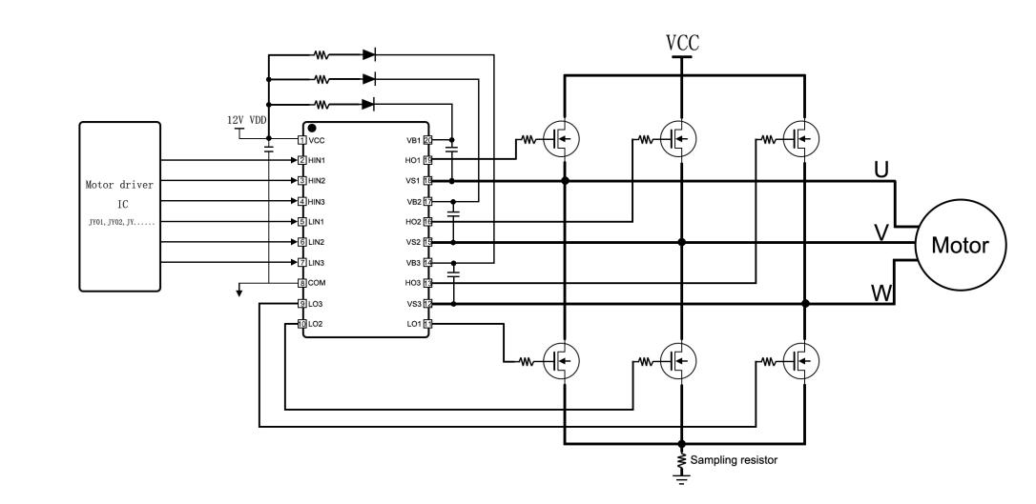
4. Typical Application Circuit

- Package & Pin Descriptions (SOP-20)
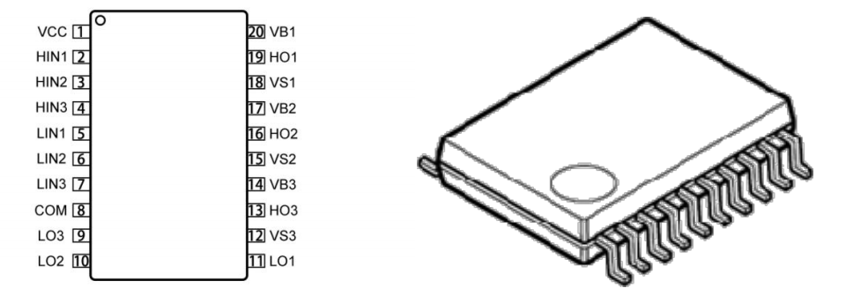

Pin Name | Pin No. | Description
VCC | 1 | Power supply input for internal logic circuits and low-side gate drivers
HIN1 | 2 | Phase 1 high-side gate driver logic input
HIN2 | 3 | Phase 2 high-side gate driver logic input
HIN3 | 4 | Phase 3 high-side gate driver logic input
LIN1 | 5 | Phase 1 low-side gate driver logic input
LIN2 | 6 | Phase 2 low-side gate driver logic input
LIN3 | 7 | Phase 3 low-side gate driver logic input
COM | 8 | Ground for internal logic circuits and low-side gate drivers
LO3 | 9 | Phase 3 low-side gate driver output
LO2 | 10 | Phase 2 low-side gate driver output
LO1 | 11 | Phase 1 low-side gate driver output
VS3 | 12 | Phase 3 high-side floating supply return
HO3 | 13 | Phase 3 high-side driver output
VB3 | 14 | Phase 3 high-side driver floating supply
VS2 | 15 | Phase 2 high-side driver floating supply return
HO2 | 16 | Phase 2 high-side driver output
VB2 | 17 | Phase 2 high-side driver floating supply
VS1 | 18 | Phase 1 high-side driver floating supply return
HO1 | 19 | Phase 1 high-side driver output
VB1 | 20 | Phase 1 high-side driver floating supply

- Absolute Maximum Ratings
Parameter | Symbol | Min | Max | Unit
High-side floating supply voltage | VB1,2,3 | –0.3 | 600 | V
High-side floating return voltage | VS1,2,3 | VB1,2,3–18 | VB1,2,3+0.3 | V
High-side gate driver output voltage | VHO1,2,3 | VS1,2,3–0.3 | VB1,2,3+0.3 | V
Low-side gate driver output voltage | VLO1,2,3 | COM–0.3 | VCC+0.3 | V
Logic input voltage (HIN1–3, LIN1–3) | VHIN1–3, VLIN1–3 | –0.3 | 20 | V
Low-side supply voltage | VCC | –0.3 | 20 | V
Allowable dv/dt | dV/dt | _ | 40 | V/ns
Junction temperature | TJ | –40 | +150 | °C
Storage temperature | TS | –50 | +150 | °C
Soldering temperature (10s) | TL | — | 260 | °C
Note: Any stress beyond the absolute maximum ratings may damage the device or cause abnormal operation. Unless otherwise specified, all parameters are referenced to the COM pin.

- Recommended Operating Conditions
Symbol | Parameter | Min | Typ | Max | Unit
VCC | Low-side supply voltage | 11 | 12 | 18 | V
VS1,2,3 | High-side floating supply return voltage① | VB1–18 | - | VB-11 | V
VB1,2,3 | High-side floating supply voltage | -8 | - | 600 | V
VHO1,2,3 | High-side gate driver output voltage | VS | - | VB | V
VLO1,2,3 | Low-side gate driver output voltage | COM | - | VCC | V
VHIN1,2,3  VLIN1,2,3 | Logic input voltage | 0 | - | 5 | V
TJ | Junction temperature | -40 | - | +125 | ℃
Note：For VBS = 12 V, to ensure proper operation of the high-side logic circuitry, the operating voltage of VS must remain within the range of -8 V to 600 V. This parameter is a design specification and is not 100% production tested.
- Block Diagram
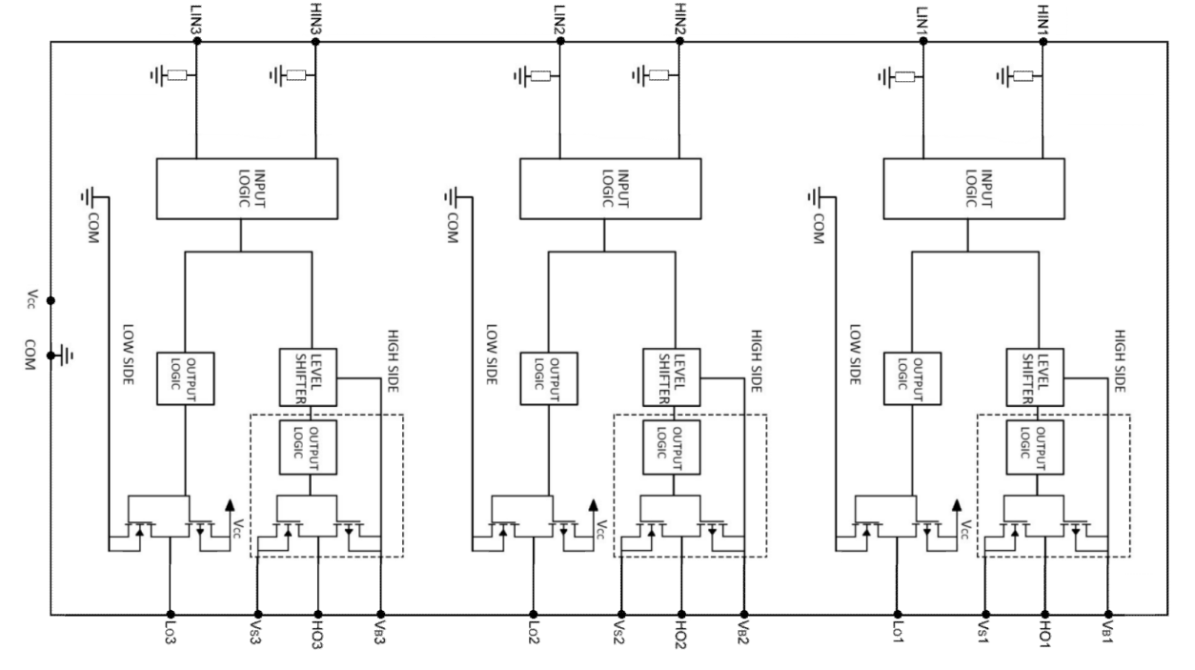

- Dynamic Electrical Characteristics
(VCC-COM) = (VB-VS)=12V, VS1,2,3=COM, Cload=1nF, TA = 25℃, unless otherwise specified.
Symbol | Parameter | Test Conditions | Min | Typ | Max | Unit
ton | Turn-on propagation delay | VHIN1,2,3 or VLIN1,2,3 = 5V, VS1,2,3 = 0 | 300 | 510 | 700 | ns
toff | Turn-off propagation delay | VHIN1,2,3 or VLIN1,2,3 = 0, VS1,2,3 = 0 | 300 | 570 | 700 | ns
tr | Turn-on rise time | VHIN1,2,3 or VLIN1,2,3 = 5V, VS1,2,3 = 0 | — | 90 | — | ns
tf | Turn-off fall time | VHIN1,2,3 or VLIN1,2,3 = 0, VS1,2,3 = 0 | — | 40 | — | ns
Tflt,in | Input filter time |  | — | 400 | — | ns
DT | Dead time |  | 150 | 230 | 310 | ns
MDT | Six-channel dead time matching |  | — | — | 100 | ns
MT | Six-channel delay matching |  | — | — | 150 | ns
PM | Output pulse width matching | PWin = 10 μs,  PM = PWout − PWin | — | — | 100 | ns

- Static Electrical Characteristics
(VCC − COM) = (VB − VS) = 12 V. Unless otherwise specified, the ambient temperature is TA = 25°C.
All input parameters such as VIN, VTH, VI, and IIN for all channels are referenced to the COM pin. Similarly, all low-side driver output parameters (VO, IO) are referenced to COM, while all high-side driver output parameters (VO, IO) are referenced to their respective VS pins.
The VCCUV parameter is referenced to COM, and the VBSUV parameter is referenced to VS.
Symbol | Parameter | Test Conditions | Min | Typ | Max | Unit
Low-side Power Supply Characteristics
IQVCC1 | Quiescent VCC supply current | VHIN1,2,3 =VLIN1,2,3 = 0 or 5V,  VENB = 0 | 200 | 350 | 500 | μA
IVCCOP | Operating VCC supply current | fLIN1,2,3 = 20 kHz,  fHIN1,2,3 = 20 kHz | — | 1200 | — | μA
VCCUV+ | Turn-on rise time | — | 8.0 | 9.5 | 11.0 | V
VCCUV− | Turn-off fall time | — | 7.3 | 8.8 | 10.3 | V
VCCHYS | Input filter time | — | — | 0.7 | — | V
High-side Floating Supply Characteristics
VBSUV+ | VBS undervoltage lockout positive threshold | — | 6.8 | 7.8 | 8.8 | V
VBSUV- | VBS undervoltage lockout negative threshold | — | 6.2 | 7.2 | 8.2 | V
VBSUVHYS | VBS undervoltage lockout hysteresis | — | — | 0.6 | — | V
IQBS | Quiescent VBS supply current | VBS = 15 V | 35 | 54 | 75 | μA
ILK | High-side leakage current | VB = VS = 600 V,  VCC = 0 V | — | — | 1 | μA
Logic Input Characteristics
VIH | Logic “1” input voltage | HIN1,2,3, LIN1,2,3 | 2.8 | — | — | V
VIL | Logic “0” input voltage | HIN1,2,3, LIN1,2,3 | — | — | 0.8 | V
VIN,TH+ | Input positive threshold voltage | — | — | 2.0 | — | V
VIN,TH− | Input negative threshold voltage | — | — | 1.5 | — | V
IIN+ | Logic “1” input bias current | VIN = 5V | — | 25 | — | μA
IIN- | Logic “0” input bias current | VIN = 0 | — | 0 | — | μA
Gate Driver Characteristics
IHO+ | High-side driver source current | VHO = VS = 0 | — | 160 | — | A
IHO− | High-side driver sink current | VHO = VB = 12 V | — | 340 | — | A
ILO+ | Low-side driver source current | VLO = 0 | — | 160 | — | A
ILO− | Low-side driver sink current | VLO = VCC = 12 V | — | 340 | — | A
VSN | Allowable negative VS voltage during normal HO operation | VBS = 12 V | — | -10 | -8 | V

- Function Description

● Low-side Supply VCC and Undervoltage Lockout (UVLO)
VCC is the power supply for the low-side circuitry, providing the necessary driving energy for the input logic circuits and the low-side output stage. The recommended operating voltage range for VCC is 10 V–18 V.
The built-in undervoltage lockout (UVLO) circuit ensures that the IC operates within a sufficiently high supply voltage range, preventing damage to MOSFETs/IGBTs caused by thermal dissipation due to low driving voltage.

As shown in the figure below, when VCC rises and exceeds the threshold voltage VCCUV+ = 9.5 V, the low-side control circuit is unlocked and begins operating, and LO starts outputting. Conversely, when VCC falls below the threshold voltage VCCUV− = 8.8 V, the low-side circuit is locked, the IC stops operating, and LO ceases output.
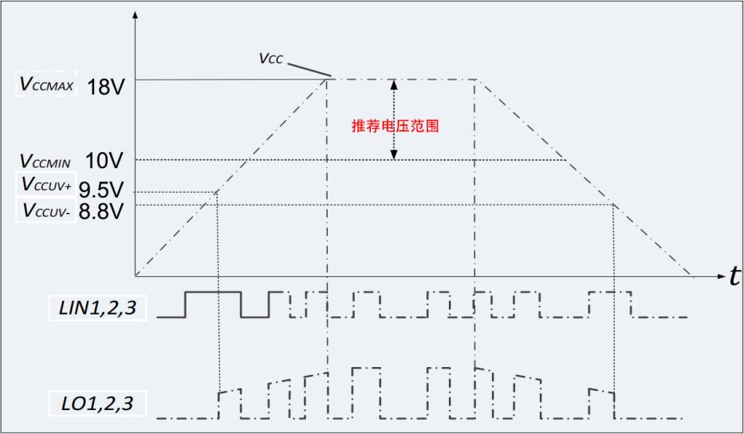

● High-side Supply VBS (VB1-VS1, VB2-VS2, VB3-VS3) and Undervoltage Lockout (UVLO)
The VBS supply powers the high-side circuitry, where VBS1 (VB1-VS1), VBS2 (VB2-VS2), and VBS3 (VB3-VS3) correspond to the high-side driver supplies for phase 1, phase 2, and phase 3, respectively.
The entire high-side circuit, powered by the floating supply VBS, references COM as the ground and follows the source/emitter voltage of the external power MOSFETs/IGBTs, swinging between the ground and bus voltage.
Because the high-side circuitry consumes very low quiescent current, it can be powered using a bootstrap circuit connected to VCC, requiring only a small capacitor to maintain the voltage needed to drive the power devices.
As shown in the figure below, the undervoltage lockout for the high-side supply VBS is similar to the low-side VCC supply. The recommended operating voltage range for VBS is 10 V–18 V.

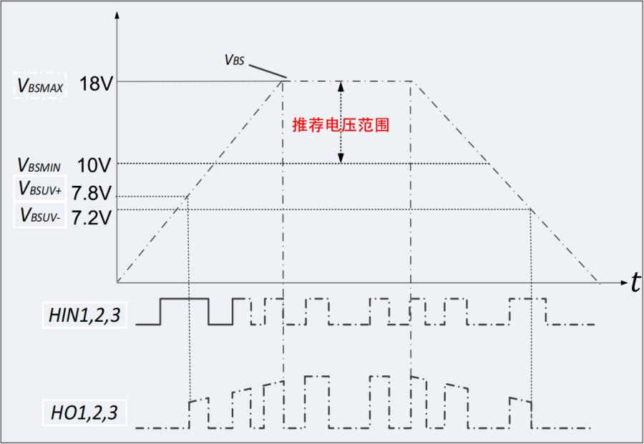

● Low-side and High-side Logic Input Control: HIN & LIN (HIN1,2,3 / LIN1,2,3)
These pins provide the control signals to turn the power devices on and off. The input pulse width should ideally not be less than 400 ns. To ensure better compatibility with various controllers, the chip specifically adjusts the thresholds of the six Schmitt inverters to support logic levels as low as 3.3 V, compatible with LSTTL and CMOS logic.
The built-in Schmitt inverters and advanced pulse filters effectively suppress abnormal short input pulses, significantly improving the system’s immunity to interference and overall reliability.
Each logic input pin includes a 200 kΩ internal pull-down resistor to ensure correct input-to-output behavior under abnormal conditions such as soldering defects (cold joints) or invalid input connections.

● Shoot-Through Prevention
The chip features an internal protection circuit specifically designed to prevent shoot-through in the power devices. This effectively protects the MOSFETs/IGBTs from damage caused by common-mode interference on the high-side and low-side input signals. The figure below illustrates how the shoot-through protection circuit safeguards the power devices.
Shoot-through occurs when both the high-side gate driver output (HO) and the low-side gate driver output (LO) of the same half-bridge are simultaneously “high.” This condition allows a large harmful current to flow through both the high-side and low-side devices, resulting in significant power dissipation and, in severe cases, permanent damage to the devices.
As shown in the figure, when both the low-side input (LIN) and the high-side input (HIN) of the same phase are “high,” the internal protection circuit pulls HO and LO outputs “low,” effectively turning off the power devices. When one of the input signals goes “low,” the driver output will only return to “high” after a delay equal to the dead time.
This mechanism prevents excessive switching caused by harmful short input pulses, reduces power loss, and significantly lowers the risk of damage to the power devices.
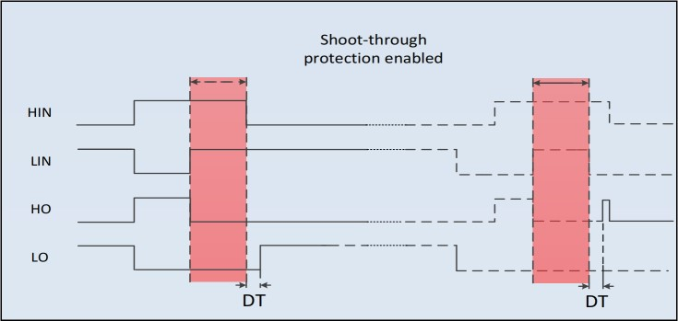

● Dead Time
The chip includes an internal fixed dead-time protection circuit. During the dead time, both the high-side and low-side driver outputs are set to “low.” The dead time is set to ensure that one power device is fully turned off before the other device is turned on, preventing shoot-through between the high-side and low-side devices.
If the externally set dead time from the logic input is shorter than the internal minimum dead time, the driver output dead time will follow the internally set value. If the externally set dead time is longer than the internal dead time, the driver output will adopt the externally set dead time.
The figure below illustrates the timing relationship among the dead time, input signals, and driver output signals.
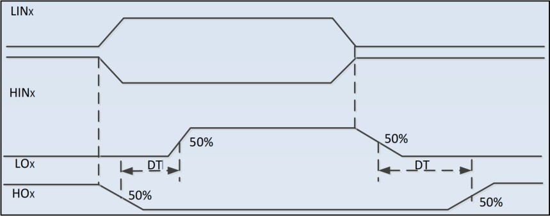

● Gate Drivers (HO1,2,3 / LO1,2,3)
The low-side and high-side drivers operate in voltage pulse output mode, making them especially suitable for driving power MOSFETs and IGBTs. The low-side driver outputs (LO1,2,3) are determined by their corresponding low-side logic inputs (LIN1,2,3), while the high-side driver outputs (HO1,2,3) are determined by their corresponding high-side logic inputs (HIN1,2,3).
It is important to note that after the high-side supply VBS undervoltage lockout is released, a new rising edge on the corresponding high-side logic input is required to reactivate the high-side output driver and set the output “high.” In contrast, after the low-side supply VCC undervoltage lockout is released, the low-side drivers immediately output the state corresponding to their respective low-side input signals, without experiencing the same requirement as the high-side drivers.

- Package Dimensions (SOP-20)
